Falmouth & Exeter Students’ Union

Student Members’ meeting
Date | Wednesday 22 February 2022 | Time | 16:00-17:00
Location | Online
Attendees | Amelia Banton (AB) Chair of Student Council (Chair)  Steven Preece (SP) President Exeter  Ben Statham-Wilkins (BSW) President Falmouth  Charlotte Agnew (CA) President Welfare & Inclusivity  Ellie Ricks (ER) President Student Experience  Sarah Davey (SD) Chief Executive  Brenda McLennan (BM) Director of Finance & Resources  Karen Draycott (KD) Project Officer
Open meeting | Available to all student members

Item and Minute
- Welcome (AB)
  - Noted: that this meeting would cover the usual formal business of a Student Members’ Meeting as well as launch the new SU Strategic Plan: Here Together 2021-2024.
- Minutes from 21 January 2021 (AB)
  - Approved: the minutes of the meetings held on the 21 January 2021 were confirmed as a true and accurate record.
  - Noted: that previous minutes and video recording of this meeting is available on the website.
- Receiving the Report of the Trustees and Financial Statements 2020/21 (SD)
  - Received: the Report of the Trustees and the Financial Statements 2020/21.
  - Noted: the SU is a registered charity and is required to be externally audited every year to ensure the charity is delivering the objectives and in line with good governance. The purpose or objectives of the SU are:
    - promoting the interests and welfare of Students at Falmouth University and the University of Exeter (Cornwall Campuses) during their course of study and representing, supporting and advising Students;
    - being the recognised representative channel between Students and Falmouth University, the University of Exeter and any other external bodies; and;
    - providing social, cultural, sporting and recreational activities and forums for discussions and debate for the personal development of its Students.
  - Noted: that as the SU is a charity, it has a Trustee Board which is the body which ensures these objectives are delivered through the services. The Trustees Report sets out how this is done in that financial year.
  - Noted: the SU income and expenditure 2021 are below:
  - 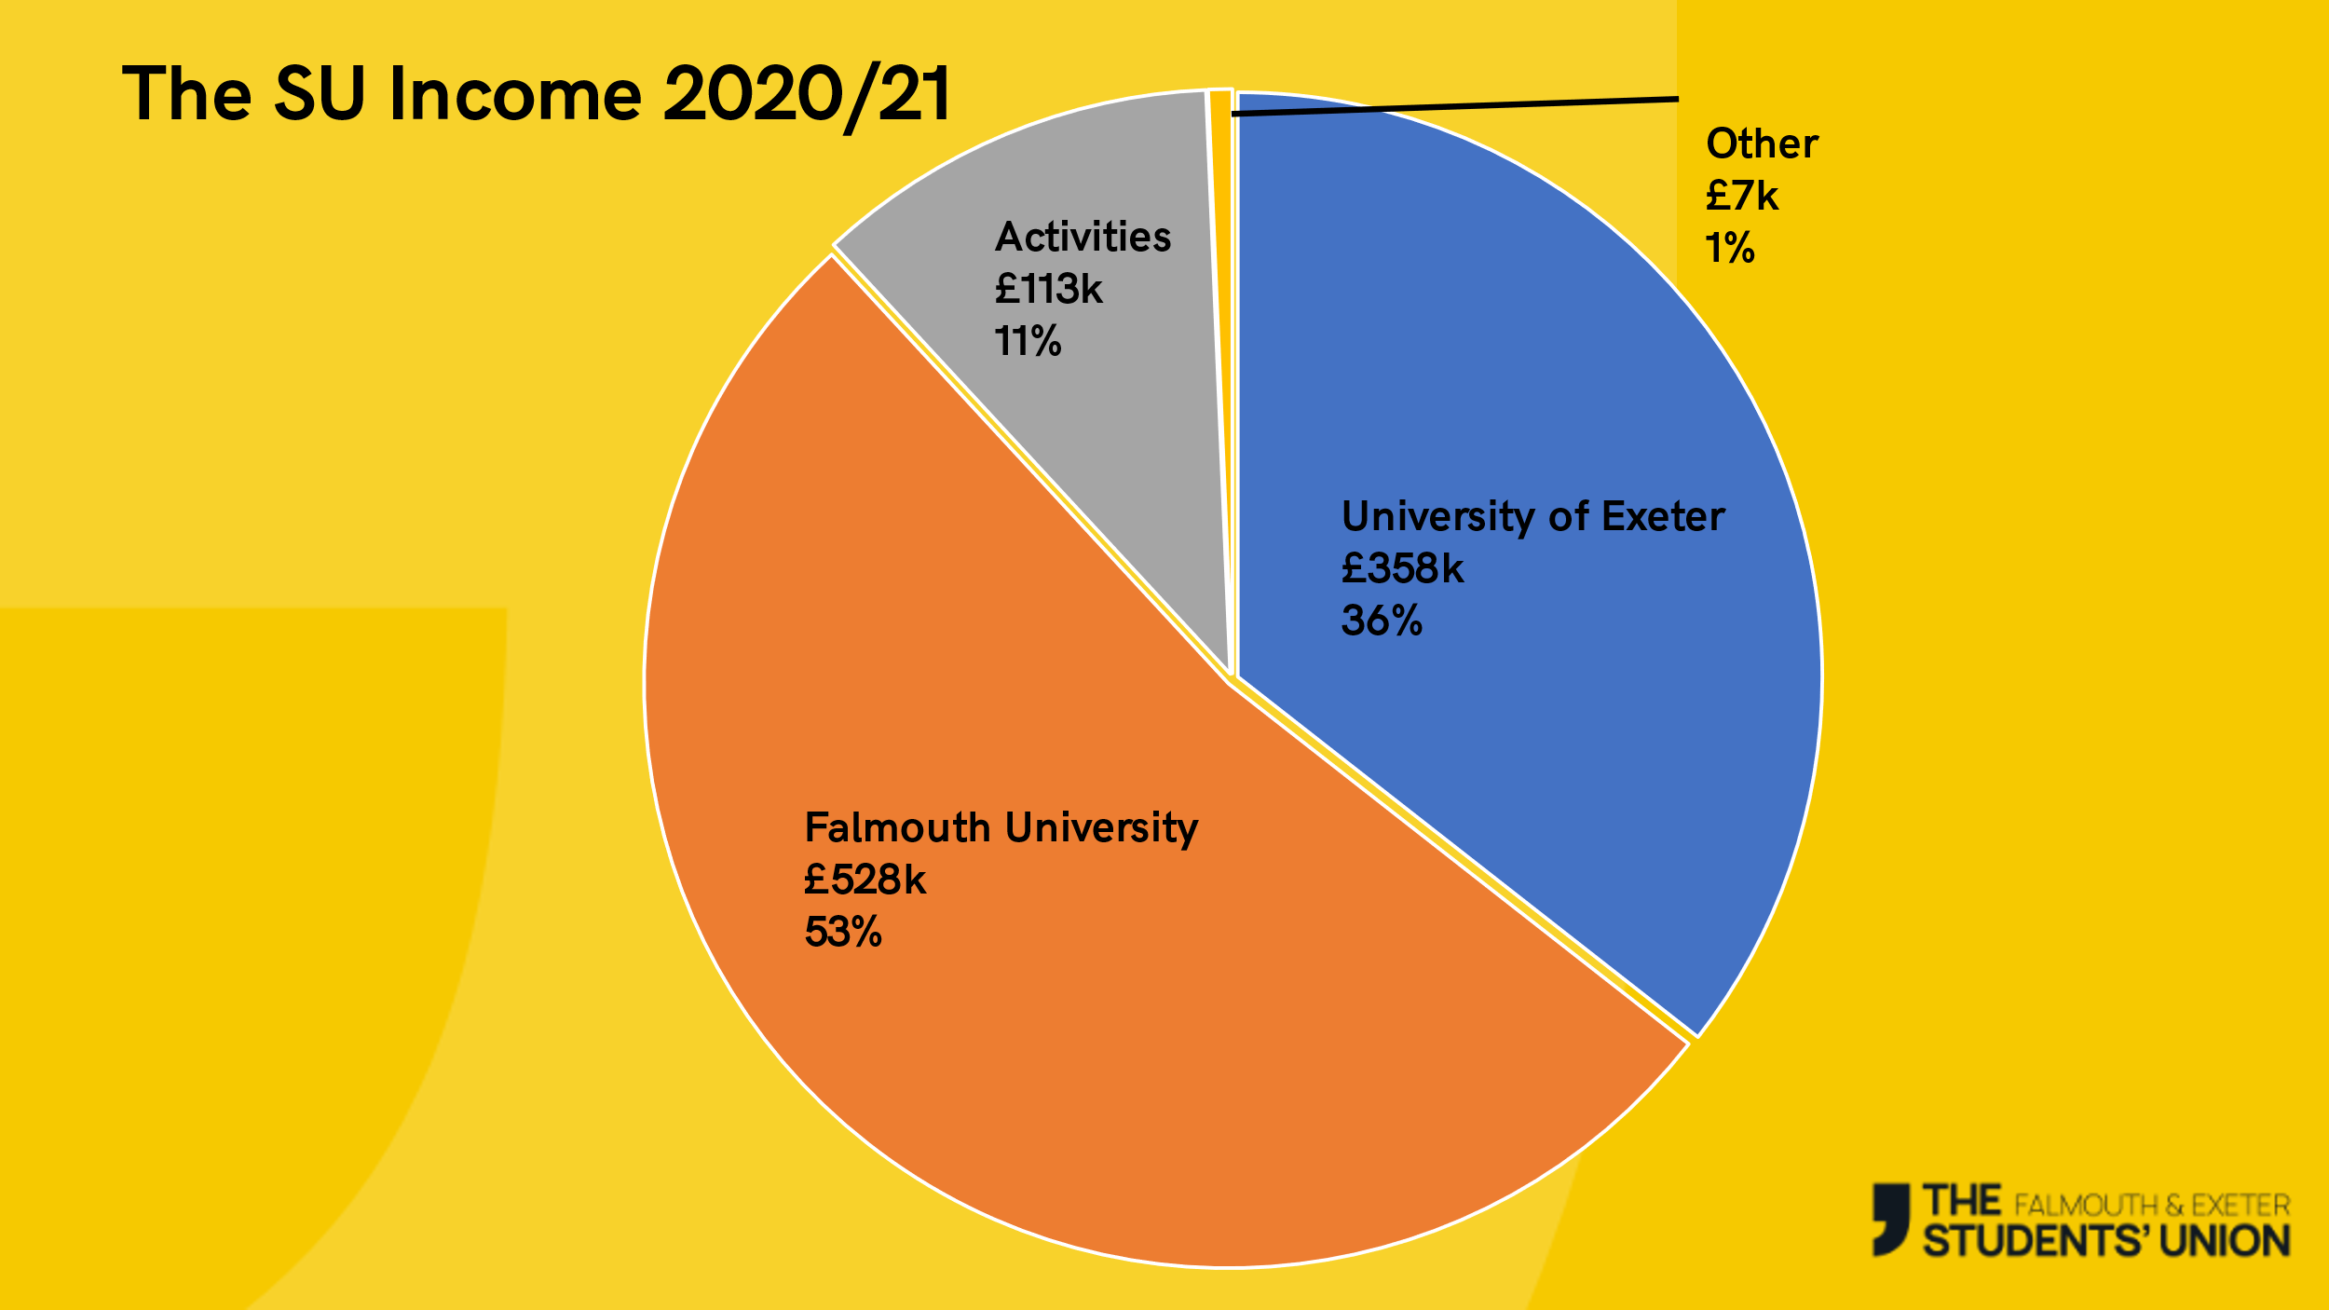
  - 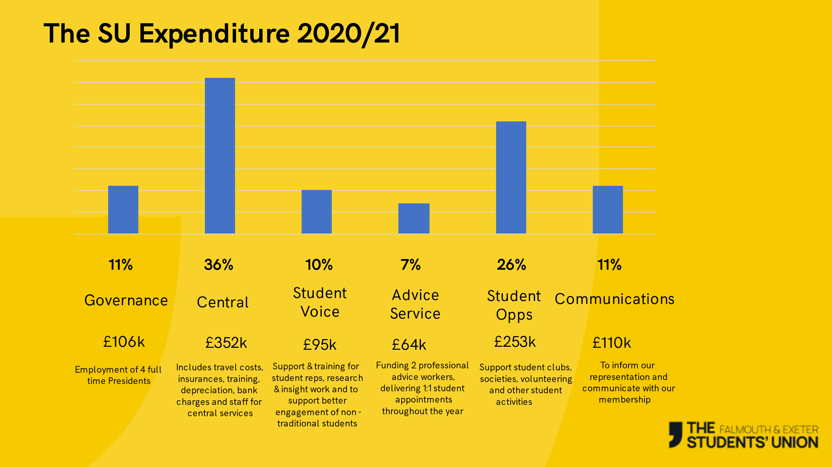
  - Noted: that the latest report is available online at the SU and the Charity Commission.
  - Noted: that this is the last year for reporting on unincorporated charity (1145405) and the charity has now incorporated and is a CIO charity (1193045).
- List of affiliations 2020/21
  - Approved: the list of affiliations 2020/21 which were National Union of Students (NUS) £16,373 and British Universities & Colleges Sport (BUCS) £1,805.
- Open questions to the Trustees.
  - Noted: that each President gave an update of their recent activities.
  - Noted: that there was an opportunity for any student member to ask a question and there were none.
- Strategic Plan Launch - Here Together 2021-2024
  - Received: PowerPoint launching the new strategic plan. Further information and the full plan can be found at https://www.thesu.org.uk/union/mission/.
- Meeting Closed

